**Risk fundamental analysis: our way of computing cost of equity and cost of capital for A2A.**

In this part we will analyse how to determine a consistent way of measuring risk for A2A.

***‣ A piece of theory***

In this contest risk refers to the likelihood investors will receive a return on a given financial asset that is different from their expected one.

In terms of equity valuation, according to DCF approach, cost of equity (and cost of capital) are key ingredient, but implicit costs which can vary across different investors.

We will focus on the most used risk and return model: the CAPM.

**‣ Steps involved in our analysis**

1) We will define risk in terms of actual returns’ distribution around an expected one.

They may be very different from the expected one and this difference represents the risk. The spread is measured using the variance (or standard deviation).

2) We make a diversification between diversifiable and non-diversifiable risk.

As well-known there is firm specific risk (project risk, competitive risk and even sector risk) which affects only a subset of entire firms and *market risk* that affects many if not all investments (i.g. an in increase in interest rates).

Expanding our investment portfolio allows us to diversify it, to reduce the exposure of firm specific risk. In fact, in this way every component will have in percentage a smaller impact on overall return. Furthermore, in very large portfolio its average impact will tend to zero.

In contrast, the effects of market wide movements are likely to be in the same directions.

3) We assume us being marginal investors.

Capital Asset Pricing Model looks at risk through the eyes of the marginal investor: a well-diversified agent; the only risk he cares is the risk added on to a diversified portfolio, the market risk.

‣ Under CAPM strict assumptions the risk of any asset becomes the risk that it adds to the market portfolio: if an asset tends to be correlated with market portfolio in movements (not independent) it will add risk to the market portfolio.

Statistically, we can measure the risk added by an asset by its covariance with that portfolio: if we standardize this percentage value by dividing with variance of the market portfolio (of the average asset) we will obtain the **Beta**.

$β_{i}=\frac{{Cov}_{iM}}{ϑ_{M}^{2}}$ it represents, in one figure, the exposure of an asset to all market risk

According to CAPM the cost of equity is given by the following formula:

$$E\left[r_{i}\right]=r_{0}+ β_{i}\left(M_{risk prem}\right)$$

Our analysis starts by finding all these three inputs: 1) Risk free rate, 2) Market risk premium (better said, equity risk premium) and 3) CAPM Beta for A2A.

**‣ 1) First component of risk: risk free rate**

We can define it as the asset of which the investor knows the expected return with certainty (i.e. to have an actual return equal to the expected one).

For an investment to be risk free, two conditions have to be met:

* There has to be no default risk
* There can be no uncertainty about reinvestment rates: no intermediate cash flows.

Therefore, we must orient towards a government bond (default risk free) not paying cash flows (zero coupon bond).

**Our assumptions**

1) According to the fact we try to estimate cash flows in nominal terms we will use nominal risk free rates as well.

2) We make our computations according to spot rates provided by ECB on AAA government bonds. Precisely, we will use German Bunds 10 years spot rates: same currency, no default risk (AAA rating).

3) Due to coronavirus crisis we will assume as a risk-free proxy the geometric average of daily provided returns (in a year basis) over latest two years.   
The main consequence of this crisis in terms of rates is the aim of ECB to reduce interest rates in order to make it easier borrowing money for private and public sector. After coronavirus outbreak spot rates trend was decreasing.

4) But not least important: we have developed all our computations on Python using Jupiter Notebooks: for more details just check the attached file.

**Results**

We obtained a series over past two years starting in 2018-05-02 until 2020-04-29 of yearly based spot rates:

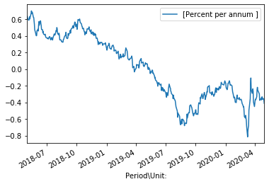

As we can see in latest part of time-range the risk free rates were dramatically negative (in percentages).

Computing a geometric mean over the series of returns we got the following result which will be used as a proxy for risk free rate: $r_{0}= -0.000720811461=$ $-0.0720811461\%$ approximately equal to 0.

**‣ 2) Second component of risk: market risk premium**

**What is it?**

The risk premium measures the extra return that would be demanded by investors for shifting from riskless investments to an average risk investment.

It is function of:

1) Risk aversion of investors: the higher aversion the higher should be the premium.  
2) Riskness of average risk investment.

Since each investor is likely to have a different assessment of an acceptable premium, it will be a weighted average of individual's with weights wealth brought to the market.

**How did we measure it? By using historical premiums**

Indeed, focusing on historical data, is the most common approach to estimate risk premium.   
In CAPM it's computed to be the difference between average returns on stocks and average returns on risk free securities (remark: 𝛽 is assumed to be 1).

**Country risk premium, a component to be included**

Italian stock market is a mature market we have a relevant historical background and lots of trades day by day. Anyway, the country has a huge public debt which, over the years, has pushed the Country Rating toward BBB (according to S&P rating agency).

This element must be included: in fact, with respect to a no-default risk government (in our case, according to risk free rates, Germany) the risk premium must be enlarged by this spread; it must capture this additional component of risk.

**Our assumptions**

1) Due to the fact we have considered a German risk-free rate, by consistency we will compute the equity premium in this market and then add it the Italian country risk component.

2) The german risk premium will be computed not with an implied approach but using a time series of "Dax" index over last 5 years (weekly returns then converted into annual nominal returns).

3) We will use *country default spread* for Italy that we can find in Aswath Damodaran's database.  
Then, in order to get the country risk premium we will rescale it using as scale factor volatility of Italian market (FTSE MIB in past years) over volatility in Italian bond market (as proxy an ETF on BTP’s)

4) Finally, to encapsulate coronavirus impact we will add a further risk component we have decided to differentiate in our individual forecasts.

Simone will use a further risk premium given by the percentual drop in price A2A’s shares suffered from during the outbreak. This component will be diluted in two years considering it as something investors expect A2A to reach in order to shift to “before Covid19” conditions.

**Analytics: step-by-step**

Again, for further information follow Python Notebook. Here will be presented main results.

We downloaded Dax daily prices over last past 5 years before Coronavirus outbreak: from 2015/02/15 to 2020/02/15.

This plot represents Dax price over sample period.

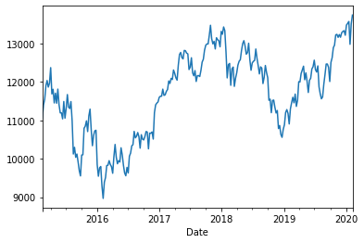

We deliberately excluded latest prices to not consider the drop which would have biased our result.

Due to the fact Dax was priced according to business days, after some arrangements we computed weekly log returns over time and the average weekly log return.

Then we plotted these results again for a graphical comparison:

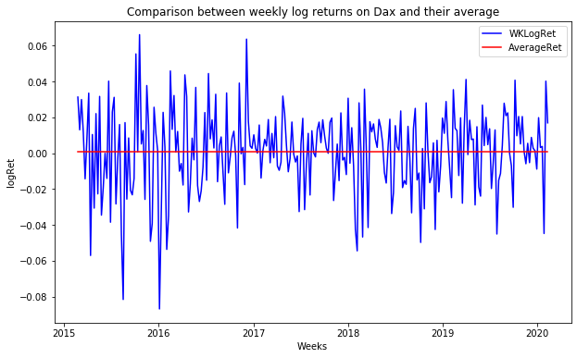

As we can see from the two plot there are outliers in our computation which reduces the average value for a bit.

Finally, in order to get German market risk premium we converted this rate into annual and then subtracted risk free rate according to the following inverse formula:

$M_{rp }=\left(E\left(r_{D}\right)- r_{f}\right)* \frac{1}{β_{M}}$, where expected return is given by log return on Dax, risk free rate the rate previously computed and Beta, the market Beta which is 1.

This yields to a proxy for German (stable) market risk premium equal to 2.9966%.

It remains to adjust this result with Italian country risk premium.

We used the following formula to retrieve a proper market risk premium for Italy: $CRP=CDS*\frac{ϑstock}{ϑbond }$. According to Damodaran’ s dataset we used a CDS of 230 BP (2,30%) and computed standard deviation respectively over FTSE MIB log returns (italian stock market proxy) and log returns for an ETF for Italian BTP (Italian bond market proxy) over the same time period.

At the end we got as Country risk premium the following one: 4.0205 %.

Adding it to the previous stable market risk premium we obtain an equity risk premium of approximately 7.017% (against a 10% from update Damodaran’s dataset: it makes sense, we did not consider Coronavirus outbreak)

**‣ 3) Third component of risk: CAPM Beta**

There are two main ways in order to obtain the Beta:

1) Regression Beta: running regressions of A2A’s returns against proper proxy for the market

2) Fundamental Beta: alternative and most reliable approach which consists of breaking down beta into its fundamental components.

We focused on regression Beta due to the fact A2A’s balance sheet was not enough clear in order to compute a nice enough bottom-up beta. Anyway, we tried in a sophisticated way to compute it, results at the end.

**‣ Regression Beta work-around**

For publicly traded firms it's straightforward to estimate returns an investor would have made on its equity over a given period. These returns can be related to a proxy for the market portfolio to get a beta approximation.

* Standard procedure: regress stock returns (A2A's performance in our case) against market returns (FTSE MIB returns).
* Regression method: OLS linear regression of the form $R_{i}= α+ βR_{M}$

The slope of regression line is the beta of the stock and measures its risk. Obviously is an estimate which comes with a standard error representing how it is noisy.

**‣ Our decisions in estimating**

*a) Length of estimation period*: we have decided to use latest 10 years as length, excluding the coronavirus outbreak period.

*b) Return interval:* due to trade-off between bias in estimations and lack of enough observations we have decided to use weekly returns.

c*) Market index proxy*: as we have already done we continue with *FTSE MIB100* index as proxy of portfolio market. We also have tried to regress it against a European index which includes A2A in its composition: *EUROSTOXX 50.*

From Investing.com we downloaded data time-series for A2A and FTSE MIB100 and in the same way we computed their log returns over the period on a weekly basis.

Then we ran a regression (again, using Python packages) getting the following results:

|  |  |
| --- | --- |
| Alpha: intercept of model | 0.000453092 |
| Beta: regression beta and slope of the model | **0.87311649** |

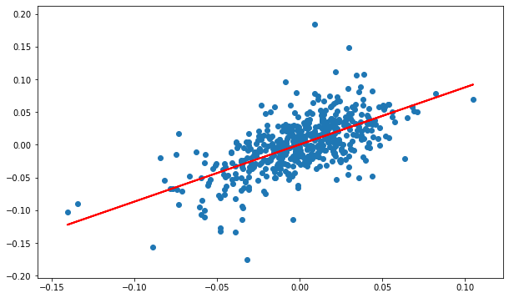

*Regression representation of A2A (on y-axis) against Italian FTSE MIB (on x-axis)*

**Another regression: against European stock market**

We also tried to regress A2A weekly log returns against Eurostoxx 50, a good proxy for European stock market.   
Why should we use this approach? According to the assumption that we should regress against a likely set of assets we could imagine that our (marginal) average investor is well diversified and active in the internationalized European stock market.

This is a good argument to use a proxy representing the average European performance: in fact, the index is compunded by most appetible shares over European scene.

Here the results over the same time period of observations:

|  |  |
| --- | --- |
| Alpha: intercept of model | 0.00016752 |
| Beta: regression beta and slope of the model | **0.87583609** |

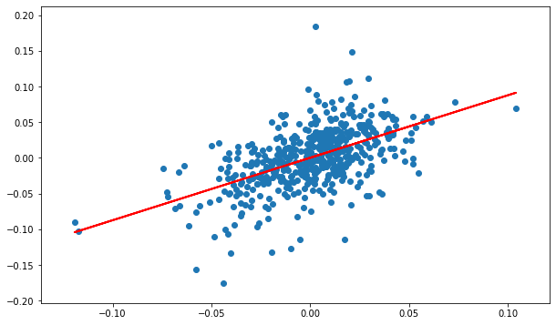

*Regression representation of A2A (on y-axis) against Italian EUROSTOXX50 (on x-axis)*

It’s interesting to notice that Beta provided by Reuters is 0.89, whereas our respectively 0.873 and 0.875.

**‣ Bottom up Beta for A2A**

**How to break down betas into fundamentals**

Breaking down betas into their business, operating leverage and financial leverage components provides us with an alternative way of estimating betas without using historical returns of that asset.

According to the following lemma beta of two assets put together is a weighted average of the individual asset betas with weights their market values. Therefore, the beta for a firm is a weighted average of betas of all different businesses it operates in.

**Bottom up beta workaround and assumptions:**

**1)** According to A2A discloses, it operates in several Business Units (see BS pag.50): most of A2A's results came from: Generation and Trading (inter-sector), Market, Waste and Networks which refers to (with large approximations) energy, water and heat distribution and waste allocation.

2) We used sector averages for unlevered betas adjusted for cash from Damodaran’s dataset: another, big assumption we made was to refer only to 4 main industries relating to utility sector where A2A operates in: Green and renewable energies, environment and waste, utilities (general and water) and gas distribution.   
Therefore, we used 5 different unlevered betas from Damodaran.

3) Strict assumptions with respect to revenues’ splitting: we considered 25 % of all energy from renewable production, we considered revenues values less inter-contribution and associate respectively Waste unit to waste sector and divide revenues from Market, Trading and Networks among remaining industries (25% of energy production is devoted to renewable sector).

4) Then we decided to use market debt to equity ratios (this allowed us to reduce Bottom up beta towards regression beta we have computed: our result it’s clearly biased by our assumptions).



This scheme tries to resume it, anyway most consistent values are Levered Betas at 31/12 using debt to equity ratio at book and market value.   
We can say however that due to difficulties with getting a proper business distinction we should follow regression beta result.

**Cost of equity and cost of capital computations**

Once we have obtained all inputs needed to get the CAPM output we can obtain easily a proxy for cost of equity.

Furthermore, we can compute (net) cost of debt in two ways:

1) Use riskfree rate and add a given default spread provided by rating agencies (S&P) for bond ratings: in our case A2A received a BBB rating for its bond issues. Damodaran provides a spread of 1.50% to add.

2) Use latest A2A emissions, compute a weighted average of their gross internal rate of return (simply provided by A2A itself) with weights: number of coupons to be paid times nominal value of outstanding bond.

This approach, preferred, provide a most updated cost of debt: in fact, A2A declared to reduce its cost of debt allowing for less expensive issues.

Finally, according to WACC we can obtain a weighted average of net cost of debt (using a marginal rate of 27.9%) and cost of equity with weights debt to capital and equity to capital.

Table below shows three possible approaches, approach number 3 which uses a regression Beta and a cost of debt in line with latest A2A debenture report is the one which will be followed in valuation (3.698 % according to Book Values).



Here the detail about outstanding bonds with different time to maturities, residual coupons and yield to maturity from which we have computed the average (gross) cost of debt for approach 3.

